INTEGRATIVE COURSE IN PSYCHOLOGY (ICOPSYCH)

ANALYSIS ON THE RESULT OF PRE-TEST EXAMINATION IN PSYCHOLOGICAL ASSESSMENT
MARCH 28, 2025

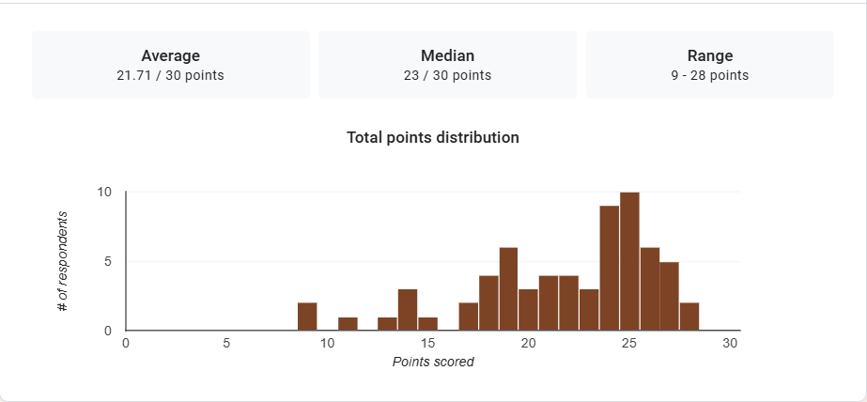

1. Mean Score: With a mean score of 21.71 out of a possible 30 points, the average score indicates that most individuals performed somewhat below the maximum possible score. This suggests that the exam may have been of moderate difficulty or that there was some level of challenge for the participants.

2. Median Score: A median score of 23 means that half of the participants scored above 23, and half scored below 23. The median being higher than the mean (21.71) suggests that there may be a skew in the distribution of scores, possibly due to a number of lower scores pulling the mean down.

3. Range: The range, which is the difference between the highest and lowest scores, is 19 points (28 - 9). This wide range indicates a significant variation in performance among the participants. Some individuals performed much better than others, with scores spanning nearly the full spectrum from the lowest to the highest possible score.

Interpretation Summary:

-The exam scores show a moderate level of performance overall, with a mean score of 21.71 and a median score of 23.

-The median being higher than the mean suggests that the distribution of scores is slightly skewed towards the lower end, possibly due to some low outlier scores.

-The wide range of 9 to 28 points indicates notable variability in participant performance, with some individuals achieving much higher scores than others.

-The data suggests that while some participants performed well, there were others who struggled significantly with the exam.

RATIONALIZATION:

DIFFICULT QUESTIONS:

